1920 Replicas – 1000 Partitions- 100 Topic

3 Producer 2 Consumer (Half Rebalancing)

Load Test Duration –15:45-16.28 (Rebalance Triggered at- 16.17)

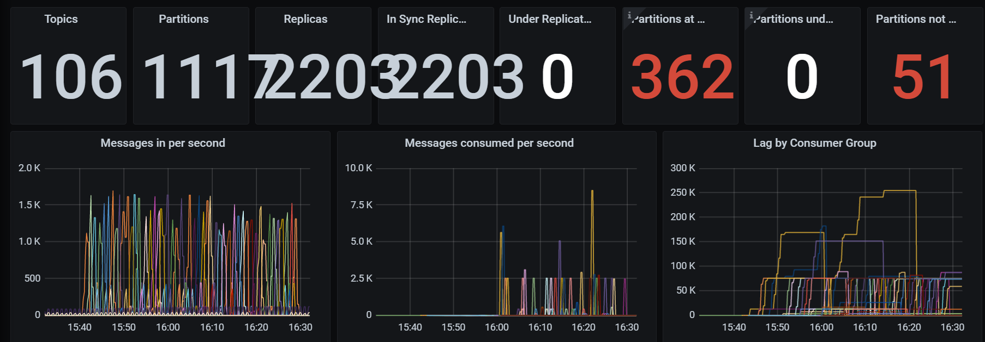

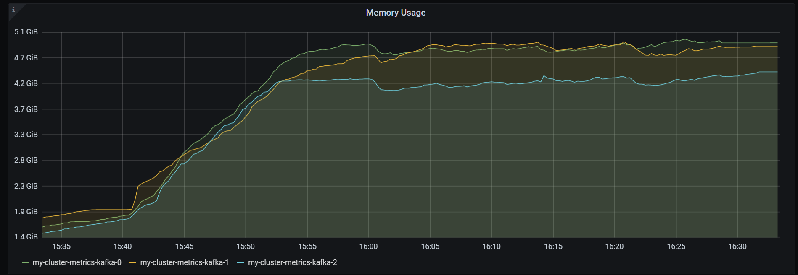

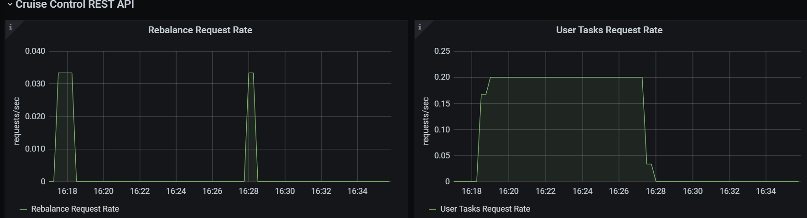

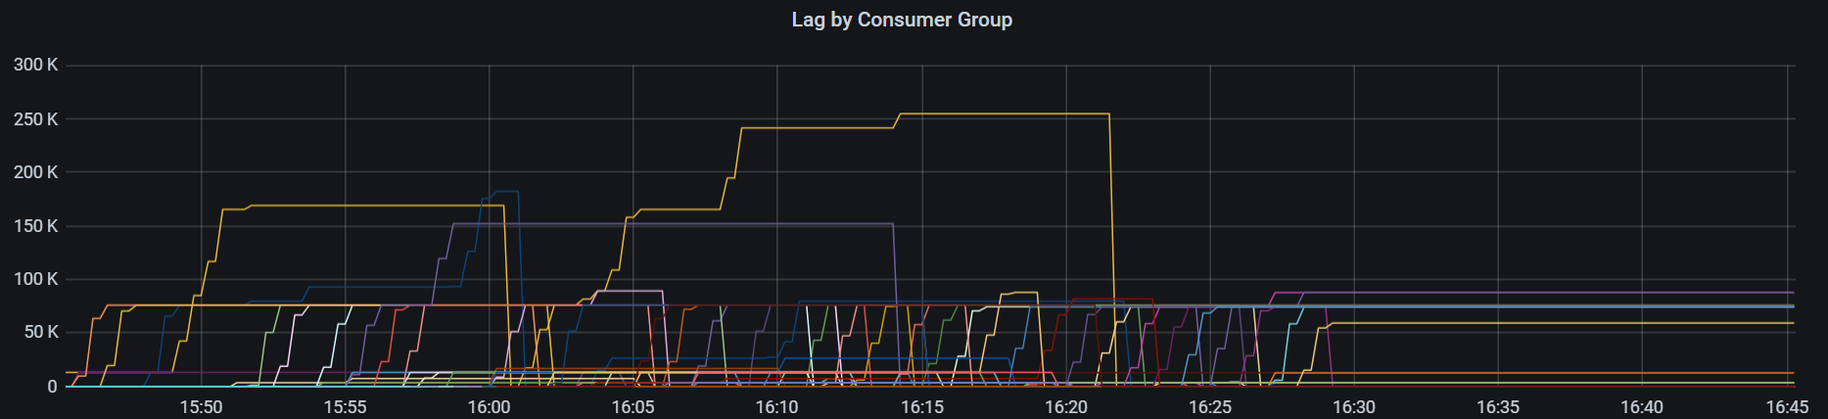

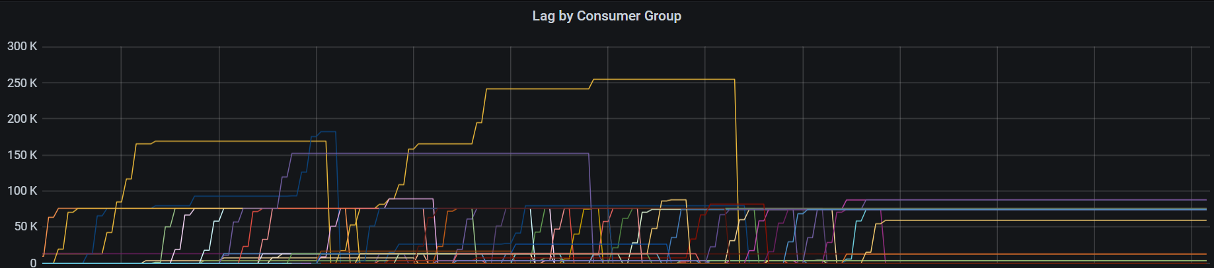

Consumer Msg Lag

69.2

78